**Exercise Week - 1**

**Complete all the exercises listed below.**

**How to add solutions to the questions**

For each question, copy your source code and paste it to Visual Studio Code. Then copy from there and paste it under the place where it says “Paste your source code below”

**Part A**

Create a new python file and name it **greeter.py.** Include a header at the top of the code as a block comment, as shown below (the header should display the correct entries, i.e., your name and today's date), and type a statement to print "Hello World!"

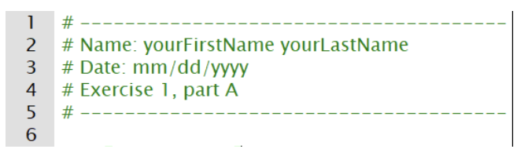

|  |
| --- |
| *Paste your source code below:*  # --------------------  # Name: Bojun Zhang  # Date: 08/30/2024  # Exercise 1, part A  # --------------------  *print*("Hello, World!") |

|  |
| --- |
| *Copy and paste a screenshot of your test results below:* |

**Part B**

Create a new python file and name it **triangle.py**. The program should print out a filled triangle four lines high. In other words, the output of this program should match the following, exactly:

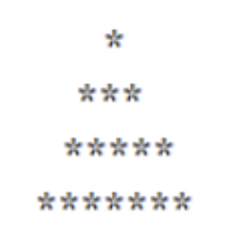

|  |
| --- |
| *Paste your source code below:*  *print*("   *")  *print*("  ***")  *print*(" *****")  *print*("*******") |

|  |
| --- |
| *Copy and paste a screenshot of your test results below:* |

**Part C**

Create a new python file and name it **numbers_calculator.py**

* Your program should print the sum of the first five odd numbers: (1 + 3 + 5 + 7 + 9)
* Then on the next line, print the product of the same five numbers. (Product means multiply. You use the symbol **'*'** to multiply in Python.
* Do not do the math on a calculator or in your head and simply display the answer. Have the computer do the work by doing the calculations inside a print() statement.

***The output:***

The sum of 1, 3, 5, 7, and 9 is 25

The product of 1, 3, 5, 7, and 9 is 945

|  |
| --- |
| *Paste your source code below:*    *print*("The sum of 1, 3, 5, 7, and 9 is", 1 + 3 + 5 + 7 + 9)  *print*("The product of 1, 3, 5, 7, and 9 is", 1 * 3 * 5 * 7 * 9) |

|  |
| --- |
| *Copy and paste a screenshot of your test results below:* |